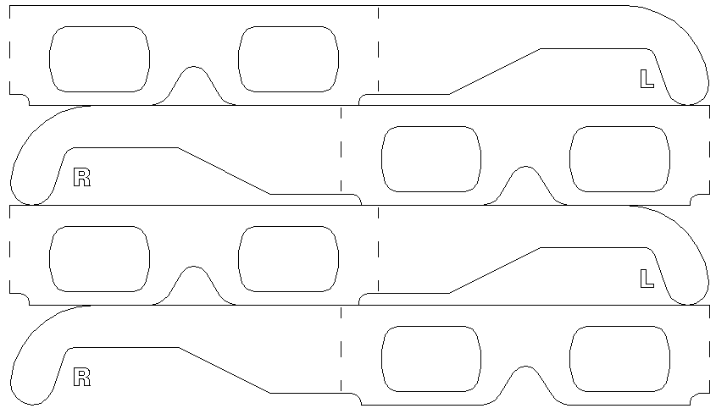



Department of Architecture

Department of Architecture

Okeil 2002
Okeil 2002
Okeil 2002
Okeil 2002
ENGEX 2002
ENGEX 2002
ENGEX 2002
ENGEX 2002
Paste Blue Cellophane here
Paste Red Cellophane here
Paste Blue Cellophane here
Paste Red Cellophane here
UAE UNIVERSITY

UAE UNIVERSITY

Paste right side here after pasting Cellophane.

Do not use water based Glue
Void
Void
Void
Void
Void
Void
Void
Void
Paste right side here after pasting Cellophane.

Do not use water based Glue

